UPDATED 2-26-2026
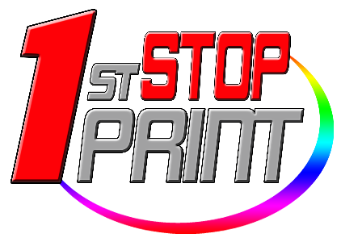
EDDM MAILER - CARDSTOCK ONLY

6.5 x 9 Inches Mailers
***Full Color - Front and Back Printing with Postage Boxes***

14pt. Cardstock – Glossy

AMOUNT | 500 | 1,000 | 2,500 | 5,000 | 6,000 | 7,000 | 8,000 | 9,000
MAIL & PRINT | $625 | $775 | $1200 | $1900 | $2200 | $2500 | $2800 | $3100
PRINT ONLY | $250 | $350 | $575 | $850 | $925 | $1050 | $1150 | $1250

AMOUNT | 10,000 | 12,500 | 15,000 | 17,500 | 20,000 | 22,500 | 25,000 | 30,000
MAIL & PRINT | $3400 | $4000 | $4600 | $5200 | $5700 | $6300 | $6900 | $8100
PRINT ONLY | $1300 | $1500 | $1600 | $1800 | $1900 | $2100 | $2300 | $2600

5.5 x 8.5 Inches Mailers
***Full Color - Front and Back Printing with Postage Boxes***

14pt. Cardstock – Glossy

AMOUNT | 500 | 1,000 | 2,500 | 5,000 | 6,000 | 7,000 | 8,000 | 9,000
MAIL & PRINT | $600 | $750 | $1100 | $1800 | $2100 | $2400 | $2700 | $3000
PRINT ONLY | $225 | $325 | $525 | $800 | $875 | $999 | $1075 | $1175

AMOUNT | 10,000 | 12,500 | 15,000 | 17,500 | 20,000 | 22,500 | 25,000 | 30,000
MAIL & PRINT | $3300 | $3900 | $4500 | $5100 | $5600 | $6200 | $6800 | $8000
PRINT ONLY | $1225 | $1400 | $1500 | $1700 | $1800 | $2000 | $2200 | $2500

